Entrainement de biceps: les 5 meilleurs exercices.
Il existe d’innombrables exercices pour les biceps. Nous allons voir les 5 les plus efficaces, et comment les combiner avec la bonne technique d’exécution.
Introduction:
Les biceps représentent un groupe musculaire le plus entrainé par les sportifs, avec les pectoraux.

Introduction of the topic in maximum of 70 words, answering the following questions:
- How many times a week should train for arm/biceps?
- Is it recommended to train for triceps or other body part at the same time?
- What is this article talking about?

How to train properly your biceps? (H2)
This paragraph introduces in minimum of 100 words the biceps muscles and how it is recommended to train it, answering the following questions:
- What is biceps, what is its function?
- How do you recommend to build up a training plan for arms?
- Why is it good to do triceps exercises on the same training?
- List the most common biceps workout mistakes at the gym.

Useful resource:
- https://en.wikipedia.org/wiki/Biceps
- https://builtwithscience.com/bicep-workout-science/ https://builtwithscience.com/how-to-get-wider-biceps/
- https://www.menshealth.com/fitness/a24740162/bicep-training-mistakes-to-avoid/
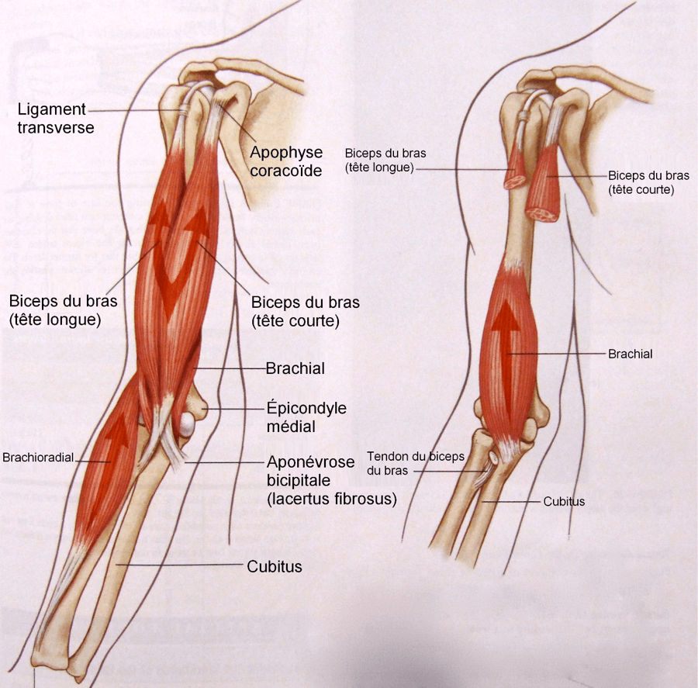

5 best biceps workout exercises (H2)
In this paragraph introduce 5 biceps exercises and explain how to do properly in minimum of 60-60 words.
- Standing barbell curl / Karhajlítás állva rúddal
- Standing cable curl / Kétkezes bicepsz alsó csigán
- Overhead cable curl / Páros bicepsz csigán
- Concentration curl / Koncentrált bicepsz hajlítás
- Scott preacher curl / Bicepsz hajlítás francia rúddal Scott-padon

Useful resource:
- https://barbend.com/bicep-curl-variations/
- https://barbend.com/best-biceps-exercises/
- https://www.menshealth.com/fitness/a19546948/best-biceps-exercises/

Biceps and triceps workout plan (H2)
Introduce a full arm workout plan with biceps and triceps exercises.
For Hungarian article copy this workout plan: https://biotechusa.hu/edzesterv/bicepsz-tricepsz-edzesnap/

